Having inserted a disciplinary record, system submits it to HR as shown below:

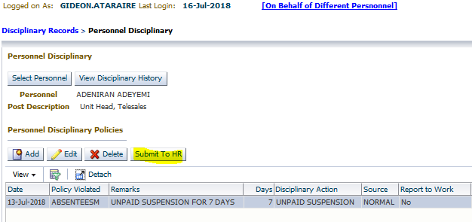

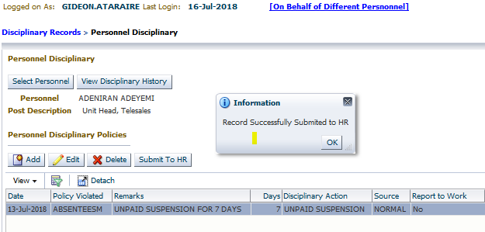

Payroll:

In order to affect amount processed in payroll we need to update the personnel’s disciplinary pay elements on the main application as shown below:

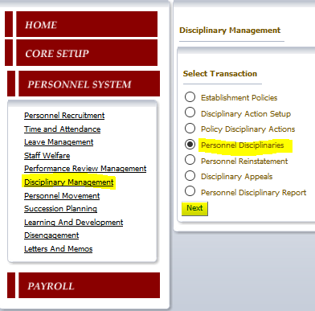

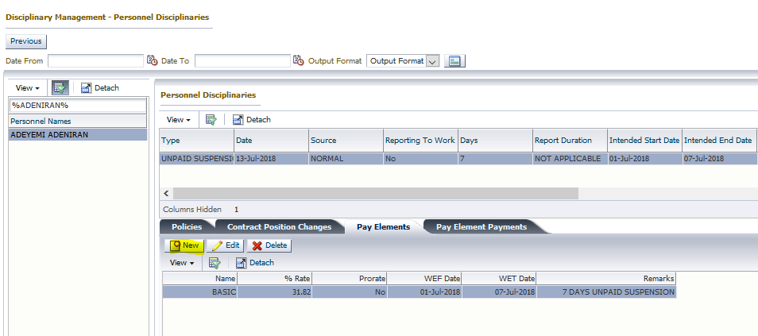

Create “New”:

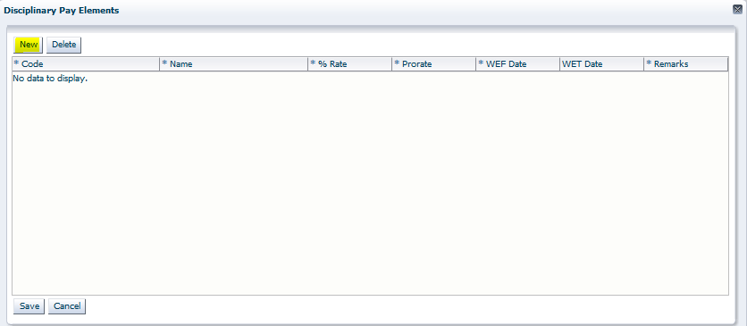

Select pay element:

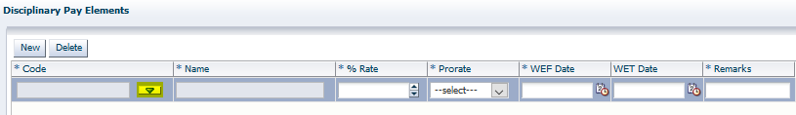

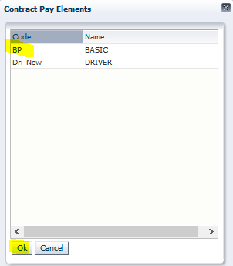

Define how the pay element (allowance) should be treated:

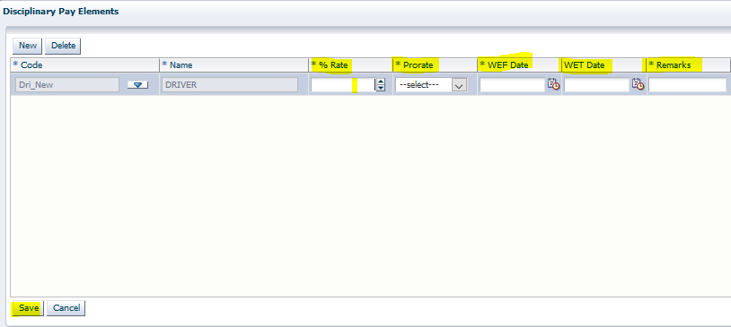

* **%Rate** = (7/22) * 100 – Since the personnel is to be suspended without pay for 7 days, and the proration denominator is 22, the proration factor is (7/22), and as a percentage it is (7/22) * 100
* **Prorate**: This should be set to “Yes”
* **WEF Date**, **WET Date**: These two dates should reflect the dates within which this proration should affect the personnel’s pay
* **Remarks**: Give a narration of the disciplinary action effected.

Once done, for all the pay elements that should be reduced, the system will penalize affected personnel by the stated factor.